LAB ASSIGNMENT -1

Team ID: 8-1 Member 1 ID: 2 Member 2 ID: 43

2) GITHUB:

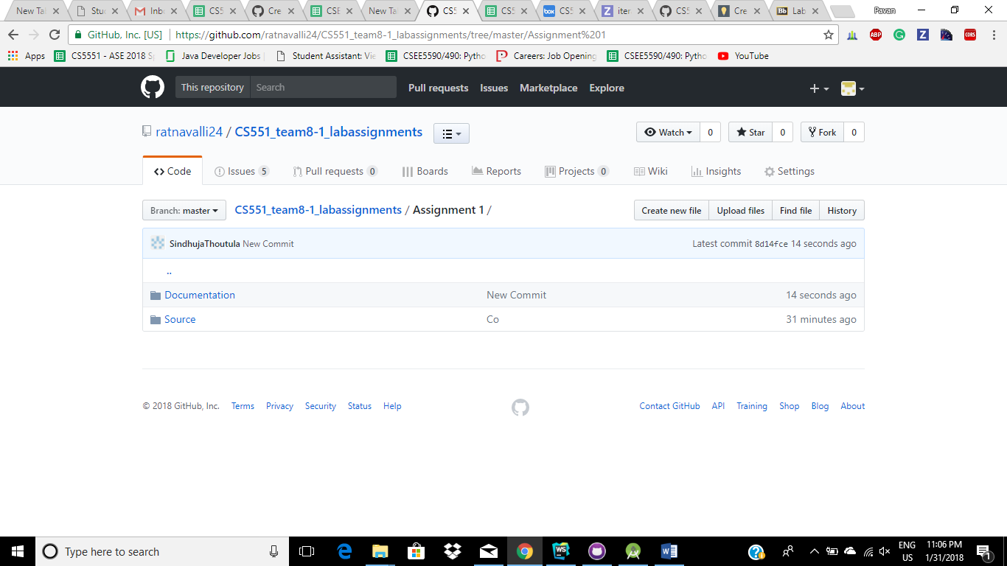

1. HELLO WORLD APP :
2. Install the android studio
3. Create a new project and name it as hello world
4. Write hello world on the blue print of android sdk selected.
5. Run it on emulator to get the hello world app
6. Screenshots are attached below

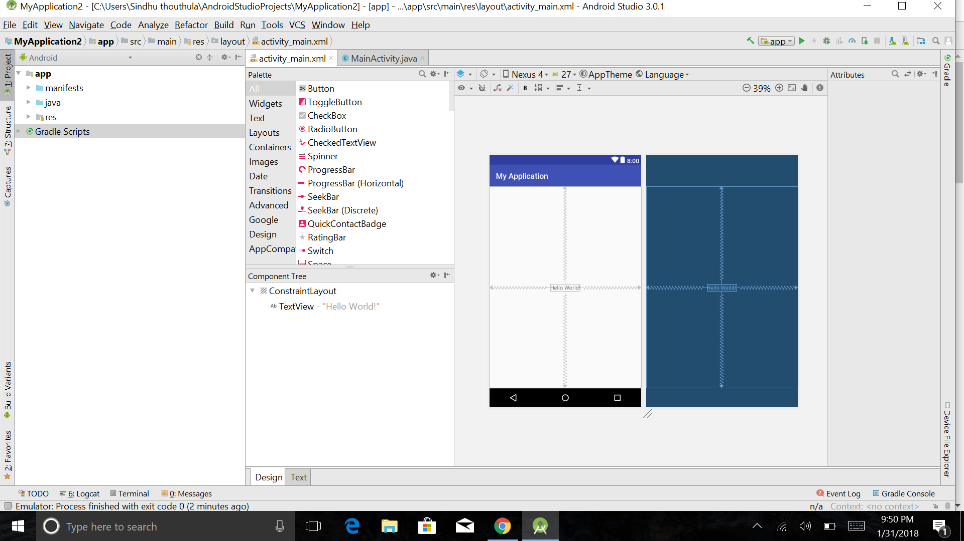

SOURCE CODE :

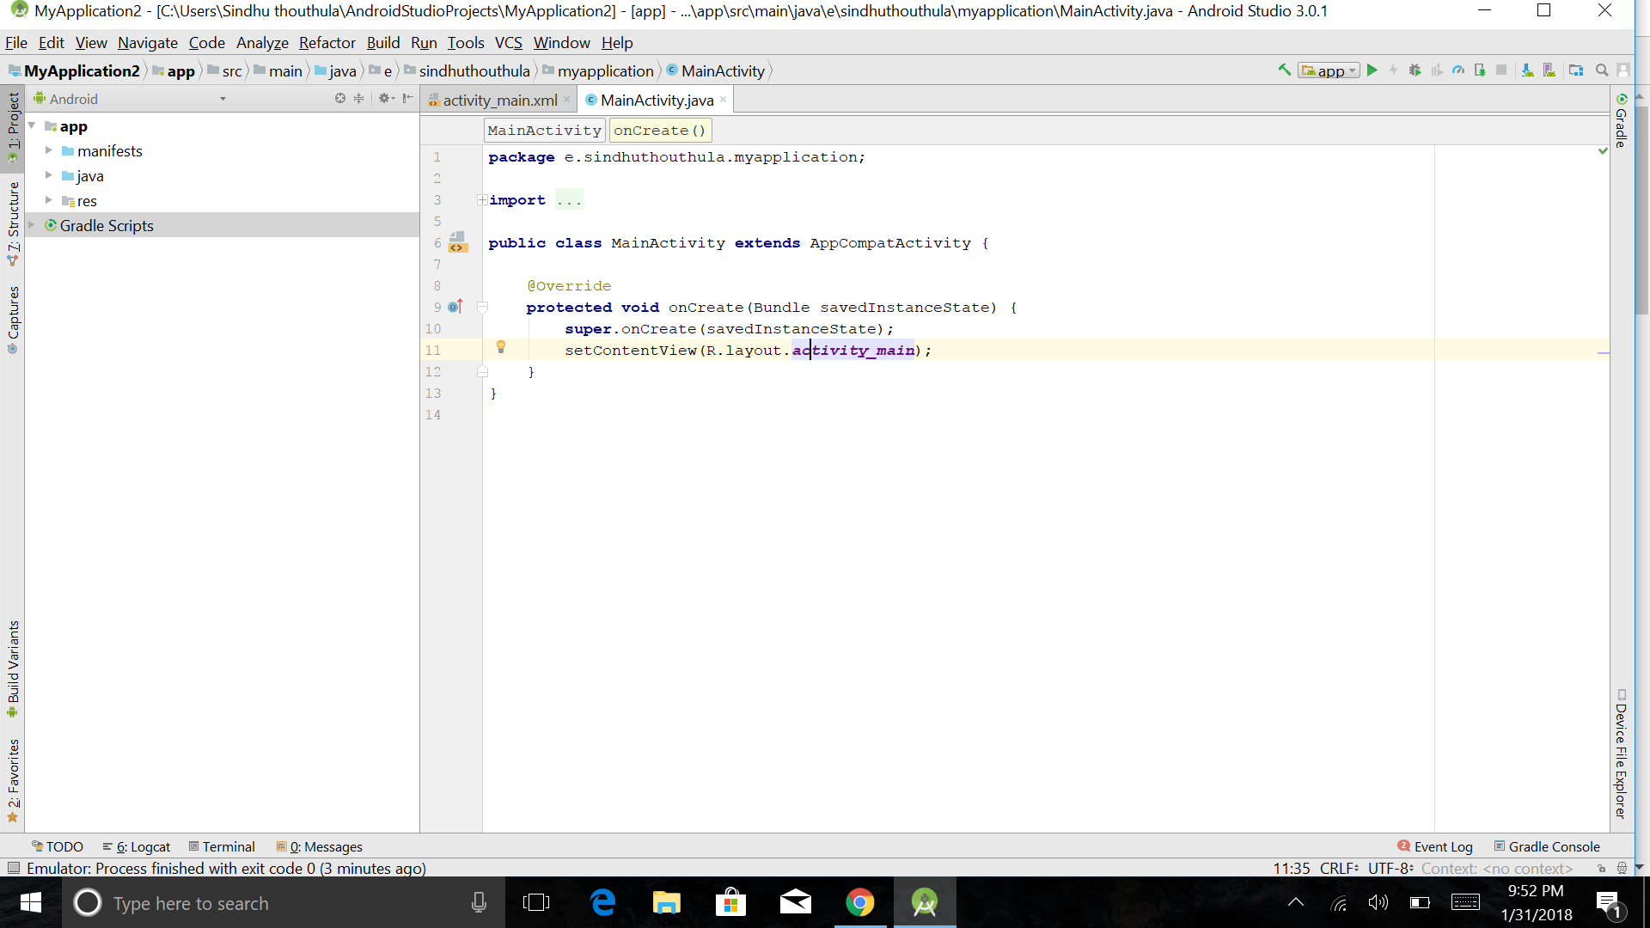

ANDROID APP IN MOBILE

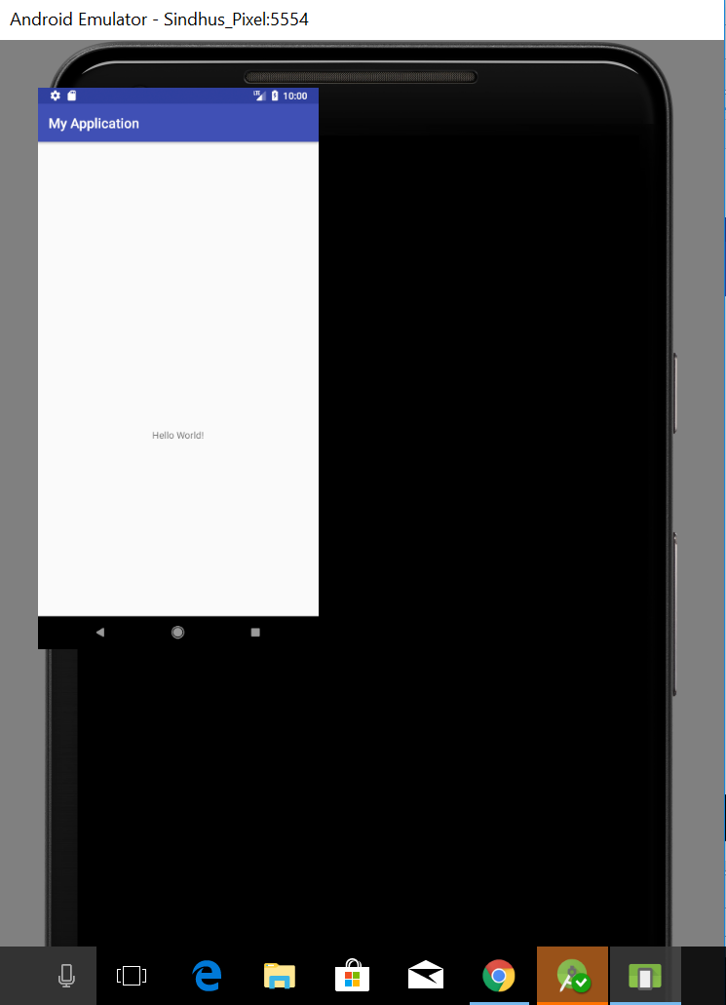

3) ZENHUB :

We have created 5 iterations, 5 Milestones and attached the screenshots below

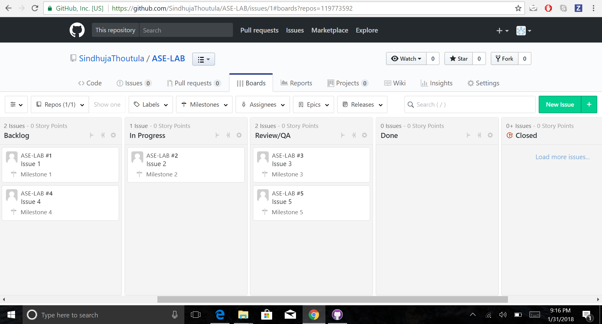

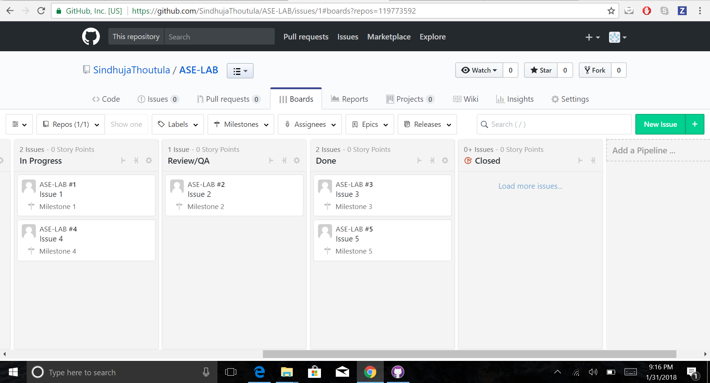

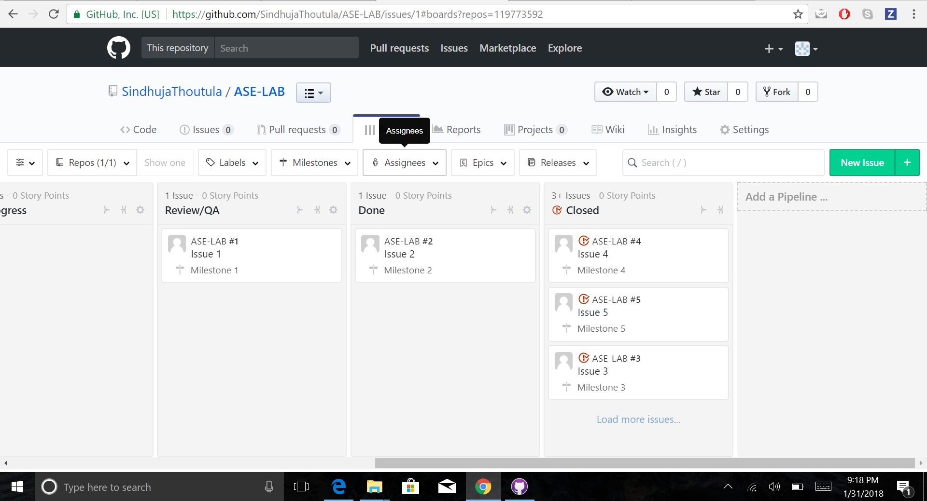

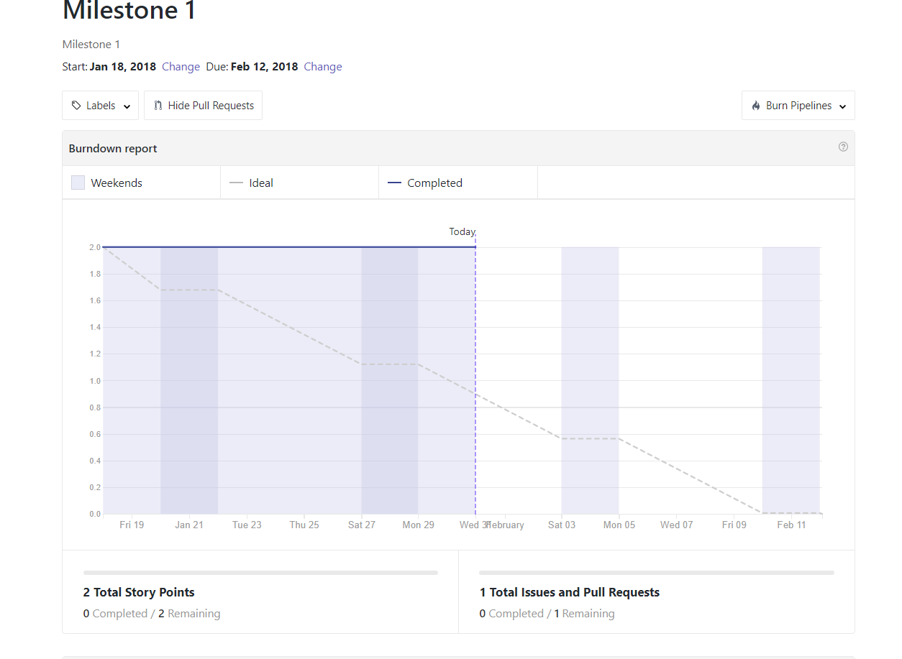

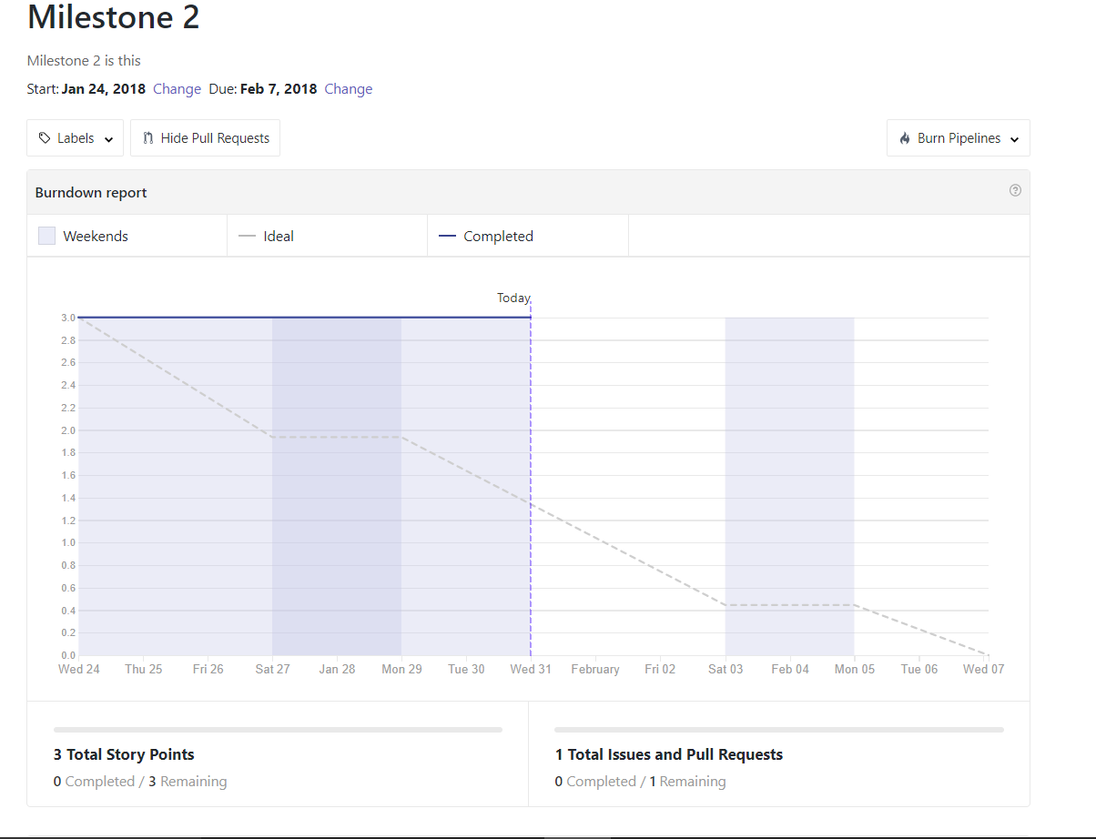

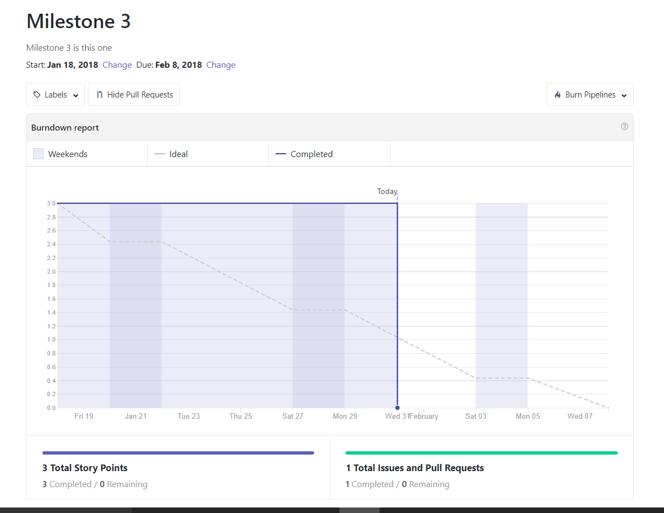

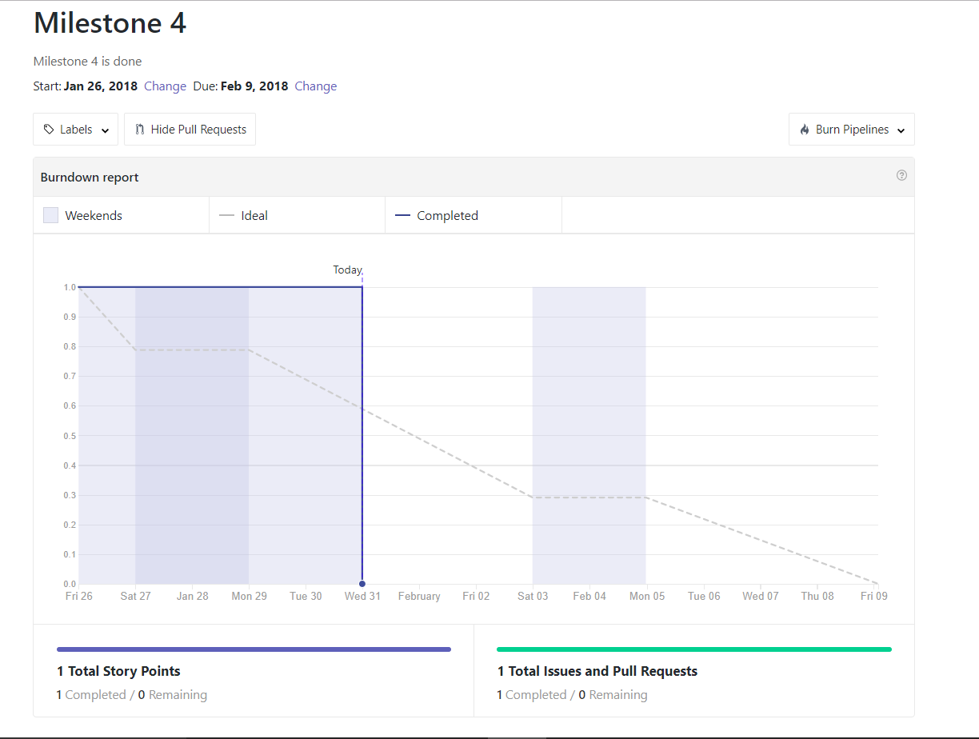

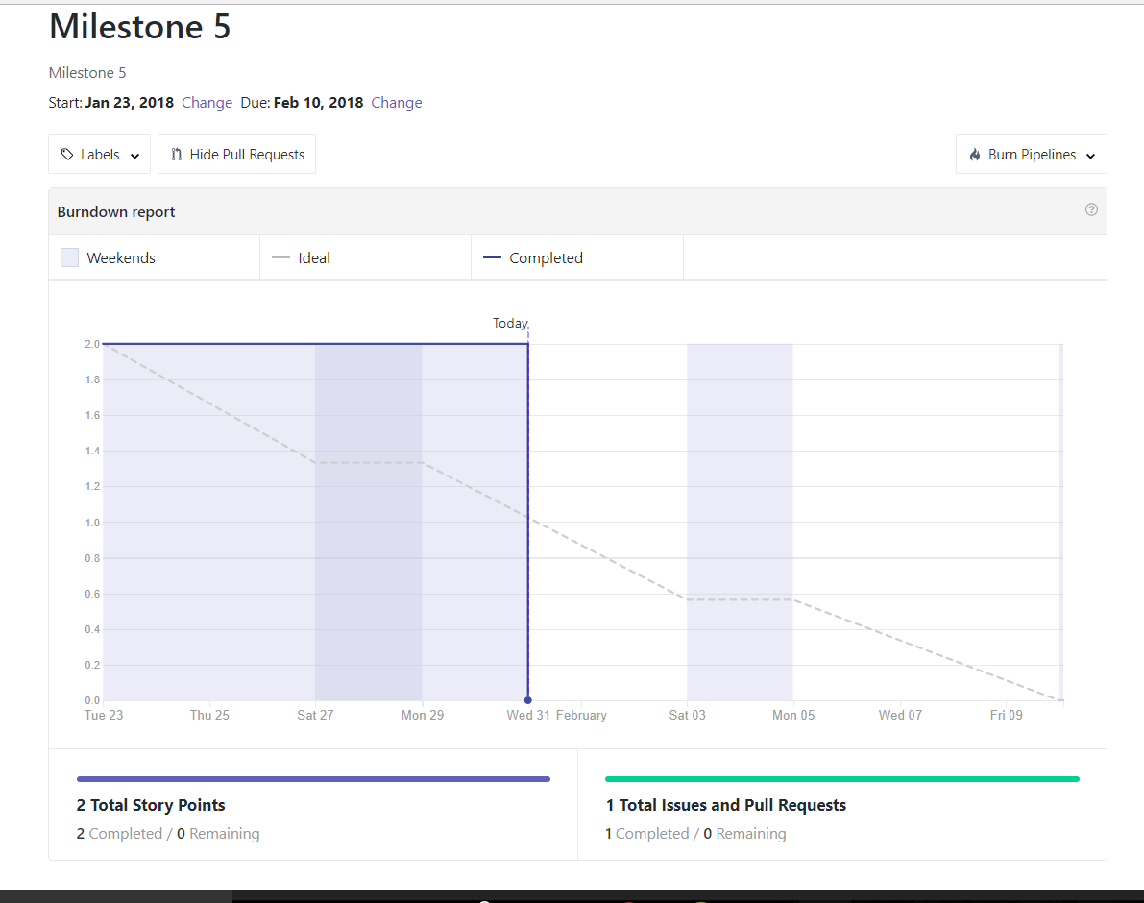

4) CONTRIBUTIONS :

Member 1 : Avasarala Ratnavalli (class ID "2")

--> Creately, Hello World, Wiki page (50%)

Member 2 : Sindhuja Thoutula (class ID "43")

--> Zenhub, Github, Wiki page, Documentation (50%)

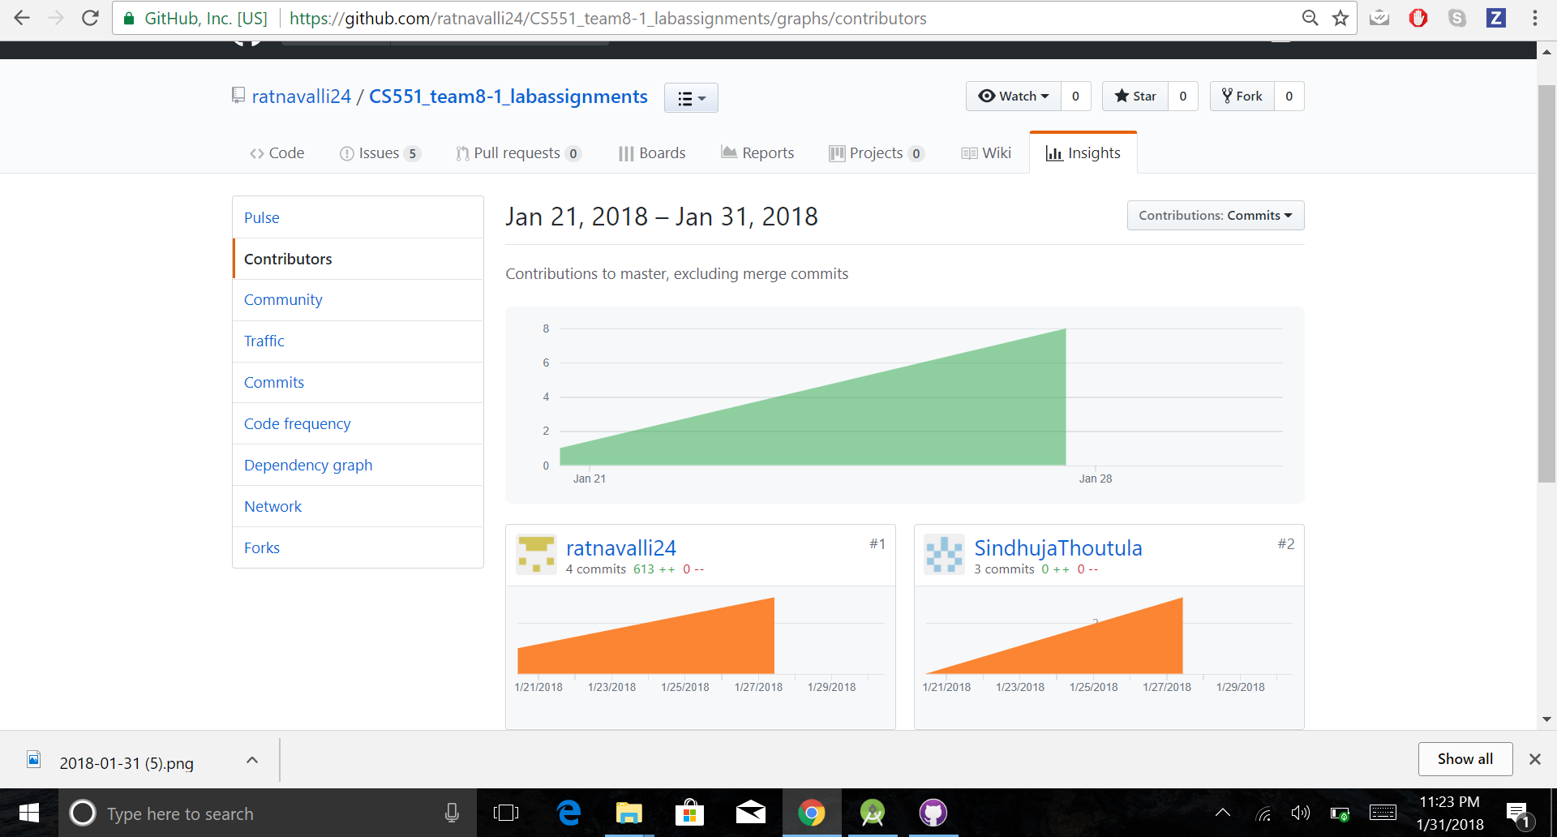

1. CREATELY CLASS DIAGRAM :

